Collections in Java
A Collection is a group of individual objects represented as a single unit. Java provides Collection Framework which defines several classes and interfaces to represent a group of objects as a single unit.
The Collection interface (java.util.Collection) and Map interface (java.util.Map) are the two main “root” interfaces of Java collection classes.
Need for Collection Framework :
Before Collection Framework (or before JDK 1.2) was introduced, the standard methods for grouping Java objects (or collections) were Arrays or Vectors or Hashtables. All of these collections had no common interface.
Accessing elements of these Data Structures was a hassle as each had a different method (and syntax) for accessing its members:
// Java program to show whey collection framework was needed
import java.io.*;
import java.util.*;

class Test
{
public static void main (String[] args)
{
// Creating instances of array, vector and hashtable
int arr[] = new int[] {1, 2, 3, 4};
Vector<Integer> v = new Vector();
Hashtable<Integer, String> h = new Hashtable();
v.addElement(1);
v.addElement(2);
h.put(1,"geeks");
h.put(2,"4geeks");

// Array instance creation requires [], while Vector
// and hastable require ()
// Vector element insertion requires addElement(), but
// hashtable element insertion requires put()

// Accessing first element of array, vector and hashtable
System.out.println(arr[0]);
System.out.println(v.elementAt(0));
System.out.println(h.get(1));

// Array elements are accessed using [], vector elements
// using elementAt() and hashtable elements using get()
}
}

Output
1
1
Geek

As we can see, none of these collections (Array, Vector or Hashtable) implement a standard member access interface. It was very difficult for programmers to write algorithms that can work for all kinds of Collections. Another drawback being that most of the ‘Vector’ methods are final, meaning we cannot extend the ’Vector’ class to implement a similar kind of Collection.
Java developers decided to come up with a common interface to deal with the above mentioned problems and introduced the Collection Framework in JDK 1.2.
Both legacy Vectors and Hashtables were modified to conform to the Collection Framework.

Advantages of Collection Framework:
- Consistent API : The API has a basic set of interfaces like Collection, Set, List, or Map. All classes (ArrayList, LinkedList, Vector, etc) that implement these interfaces have some common set of methods.
- Reduces programming effort: A programmer doesn’t have to worry about the design of Collection, and he can focus on its best use in his program.
- Increases program speed and quality: Increases performance by providing high-performance implementations of useful data structures and algorithms.

Hierarchy of Collection Framework
Collection Map
/ / \ \ |
/ / \ \ |
Set List Queue Dequeue SortedMap
/
/
SortedSet
Core Interfaces in Collections

Note that this diagram only shows core interfaces.

Collection : Root interface with basic methods like add(), remove(),
contains(), isEmpty(), addAll(), ... etc.

Set : Doesn't allow duplicates. Example implementations of Set
interface are HashSet (Hashing based) and TreeSet (balanced
BST based). Note that TreeSet implements SortedSet.

List : Can contain duplicates and elements are ordered. Example
implementations are LinkedList (linked list based) and
ArrayList (dynamic array based)

Queue : Typically order elements in FIFO order except exceptions
like PriorityQueue.

Deque : Elements can be inserted and removed at both ends. Allows
both LIFO and FIFO.

Map : Contains Key value pairs. Doesn't allow duplicates. Example
implementation are HashMap and TreeMap.
TreeMap implements SortedMap.

The difference between Set and Map interface is that in Set we
have only keys, whereas in Map, we have key, value pairs.

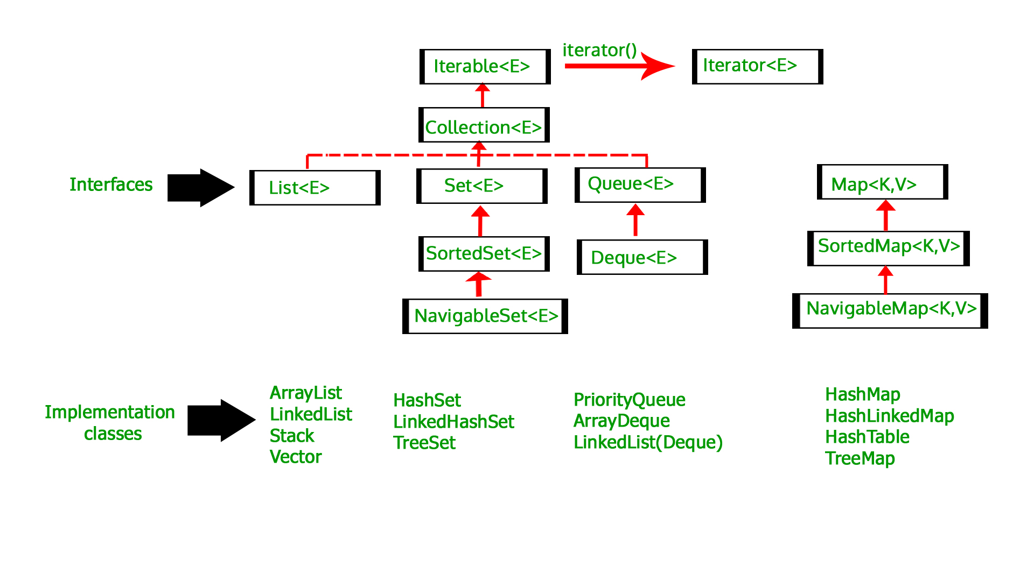

Benefits of the Java Collections Framework
The Java Collections Framework provides the following benefits:
- Reduces programming effort: By providing useful data structures and algorithms, the Collections Framework frees you to concentrate on the important parts of your program rather than on the low-level "plumbing" required to make it work. By facilitating interoperability among unrelated APIs, the Java Collections Framework frees you from writing adapter objects or conversion code to connect APIs.
- Increases program speed and quality: This Collections Framework provides high-performance, high-quality implementations of useful data structures and algorithms. The various implementations of each interface are interchangeable, so programs can be easily tuned by switching collection implementations. Because you're freed from the drudgery of writing your own data structures, you'll have more time to devote to improving programs' quality and performance.
- Allows interoperability among unrelated APIs: The collection interfaces are the vernacular by which APIs pass collections back and forth. If my network administration API furnishes a collection of node names and if your GUI toolkit expects a collection of column headings, our APIs will interoperate seamlessly, even though they were written independently.
- Reduces effort to learn and to use new APIs: Many APIs naturally take collections on input and furnish them as output. In the past, each such API had a small sub-API devoted to manipulating its collections. There was little consistency among these ad hoc collections sub-APIs, so you had to learn each one from scratch, and it was easy to make mistakes when using them. With the advent of standard collection interfaces, the problem went away.
- Reduces effort to design new APIs: This is the flip side of the previous advantage. Designers and implementers don't have to reinvent the wheel each time they create an API that relies on collections; instead, they can use standard collection interfaces.
- Fosters software reuse: New data structures that conform to the standard collection interfaces are by nature reusable. The same goes for new algorithms that operate on objects that implement these interfaces.

